| **Set 12. Connecting Networks** |
| --- |

| **Skill 12.01: Explore how the Internet works**  **Skill 12.02: Explain how computing devices can be connected to form a network**  **Skill 12.03: Describe the three different types of computer networks**  **Skill 12.04: Describe the physical connections that make up the Internet**  **Skill 12.05: Explain how bits are sent over the Internet**  **Skill 12.06: Define bit rate, bandwidth, and latency** |
| --- |

| **Skill 12.01: Describe the components of the Internet** |
| --- |

**Skill 12.01 Concepts**

The **Internet** is a global network of computing devices communicating with each other in some way, whether they're sending emails, downloading files, or sharing websites.

Watch the video below to learn more,

|  |
| --- |
| <https://youtu.be/Dxcc6ycZ73M> |

**[Skill 12.01 Exercise 1](https://hpluska.github.io/APCompSciPrinciples/ticketOutTheDoor/set8/Set8TicketOutTheDoorAPCompSciPrinciples.pdf)**

| **Skill 12.02: Explain how computing devices can be connected to form a network** |
| --- |

**Skill 12.02 Concepts**

A **computer network** is any group of interconnected computing devices capable of sending or receiving data. A **computing device** isn't just a computer—it's any device that can run a program, such as a tablet, phone, or smart sensor. The Internet is the world's largest computer network.

The simplest computer network is two devices:

A network like that only has to worry about a few things, like how to physically connect the two devices and how to send data over the physical connection in a format they both understand.

Let’s add one more device:

Now there's additional complexity. How can each device know whether incoming data is meant for them or for their neighbor? This simple network will need an addressing scheme.

Let's jump to six devices. There are actually many ways we can connect six devices together in a computer network:

Each of those arrangements is a different **network topology**, and each topology has its advantages and disadvantages.

**[Skill 12.02 Exercises 1 & 2](https://hpluska.github.io/APCompSciPrinciples/ticketOutTheDoor/set8/Set8TicketOutTheDoorAPCompSciPrinciples.pdf)**

| **Skill 12.03: Describe the three different types of computer networks** |
| --- |

**Skill 12.03 Concepts**

We use different terms to refer to different networks based on their size and characteristics. Let's touch on a few of them here.

The most common type of network is the **Local area network (LAN)**, a network that covers a limited area like a house or school.

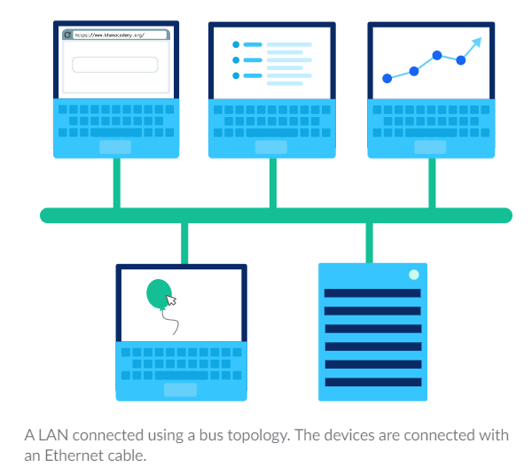

The largest type of network is a **Wide Area Network (WAN)**, a network that extends over a large geographic area and is composed of many, many LANs. Oftentimes, the networks in a WAN can only be connected by leasing telecommunications lines from different companies, since no single company owns all the infrastructure across the wide geographic area.

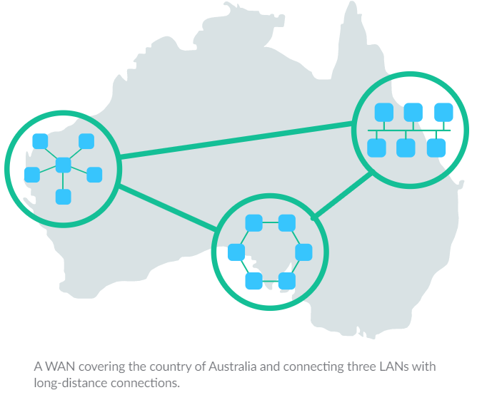

Another type of network is the **Data Center Network (DCN)**, a network used in data centers where data must be exchanged with very little delay.

**[Skill 12.03 Exercise 1](https://hpluska.github.io/APCompSciPrinciples/ticketOutTheDoor/set8/Set8TicketOutTheDoorAPCompSciPrinciples.pdf)**

| **Skill 12.04: Describe the physical connections that make up the Internet** |
| --- |

**Skill 12.04 Concepts**

The Internet is a network of computers connected to each other. But what does each physical connection look like? It depends on the needs of the connection and the size of the network.

Copper cables

Since the landline telephone system originally used copper wires, the first Internet connections reused that technology and many still use it today.

If you're in a computer lab or near a modem, you can probably find a cable similar to this one:

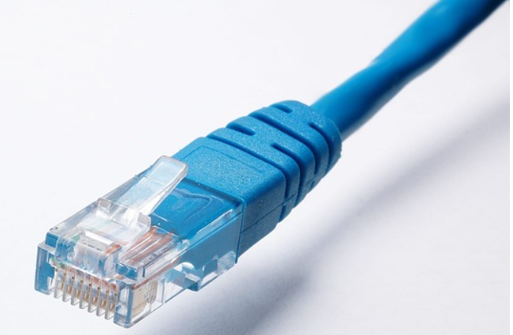

That's a CAT5 cable, a type of **twisted pair cable** that's designed for use in computer networks.

If you were to look inside the cable, you would find four twisted pairs of copper wires:

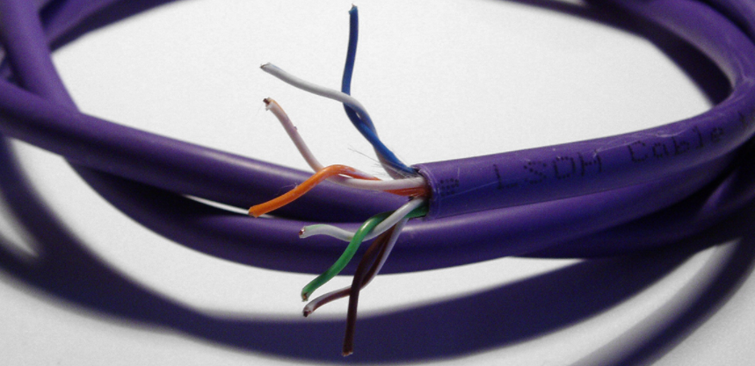

Twisted pair cables send data through a network by transmitting pulses of electricity that represent binary data:

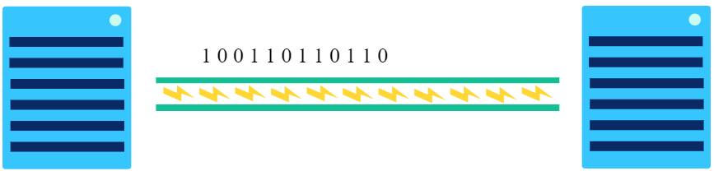

To make sure cables are transmitting information in a way that can be understood by the recipient, they follow the **Ethernet** standards. That's why twisted pair cables are commonly known as Ethernet cables.

They are used both in networks as small as a company office (a LAN) or as large as an entire country (a WAN).

Fiber-optic cables

A fiber-optic cable contains an optical fiber that can carry light (instead of electricity). The fiber is coated with plastic layers and sheathed in a protective tube to protect it from the environment.

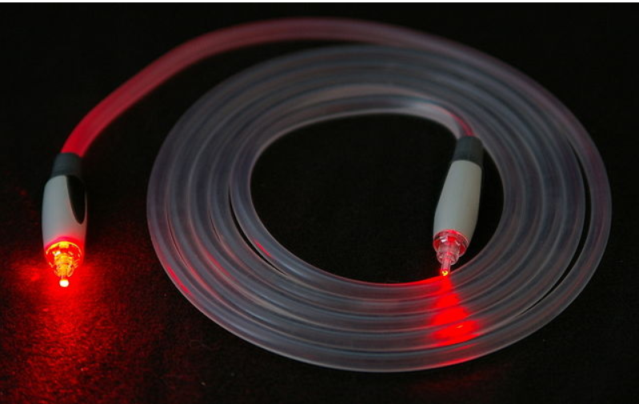

Fiber-optic cables communicate by sending pulses of light that represent binary data:

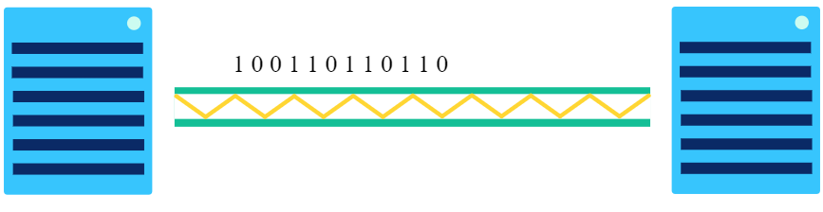

They typically also follow the Ethernet standards to make sure they're sending data in a way that can be commonly understood by any recipient in the network.

Fiber-optic cables are capable of transmitting much more data per second than copper cables. They're often used to connect networks across oceans so that data can travel quickly around the world.



As fiber-optic cables become less expensive, they're becoming increasingly common in city-wide networks as well.

Wireless

Wireless connections don't involve any wiring at all—at least at first. A wireless card inside the computer turns binary data into radio waves and transmits them through the air:

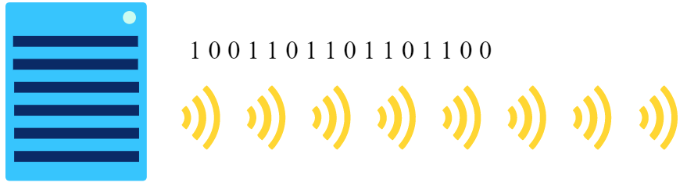

Those radio waves can't travel very far: 75-100 feet in a place like an office building that's filled with all sorts of obstacles, or up to 1000 feet in a wide open field.

The waves are hopefully picked up by a wireless access point which converts them from radio waves back into binary data. Wireless access points are connected to the rest of the network using physical wiring, like copper or fiber-optic cables.

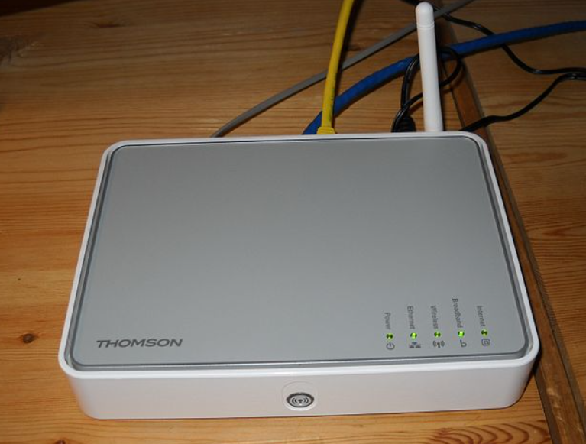

Wireless connections are limited in how much area they can cover, but they are increasingly commonplace due to the prevalent use of portable computing devices.

Summary

At any given time, our Internet connection might be using a combination of those technologies. Maybe we're using WiFi to connect to our home router, our home router is using twisted pair copper cables to connect to the metropolitan network, and those cables are hopping over fiber to communicate with overseas data centers.

Each technology has both advantages and disadvantages, so we use whatever is best for the job.

**[Skill 12.04 Exercise 1](https://hpluska.github.io/APCompSciPrinciples/ticketOutTheDoor/set8/Set8TicketOutTheDoorAPCompSciPrinciples.pdf)**

| **Skill 12.05: Explain how bits are sent over the Internet** |
| --- |

**Skill 12.05 Concepts**

All of the computing devices on the Internet are communicating in binary. Whether they are connected via wired or wireless, they are sending electromagnetic signals that represent streams of 1s and 0s.

When computers need to internally represent the number 5 (101 in binary), they can use three wires to represent the three bits: one wire on, one wire off, one wire on.

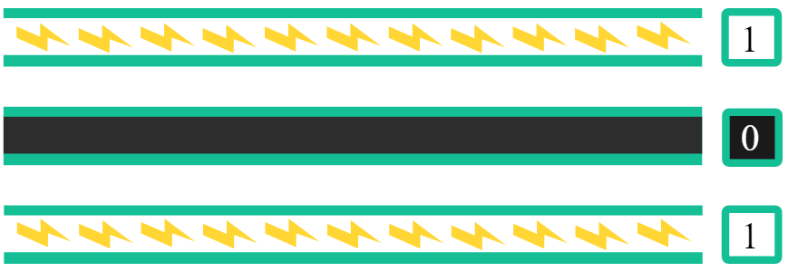

If a computer wants to send the number 5 to another computer, they can't use as many wires as they want. In fact, they may only have a *single* wire to send information over. Instead, they can send the number 5 over three time periods: first sending an on pulse (and waiting), then sending nothing (and waiting), then sending an on pulse.

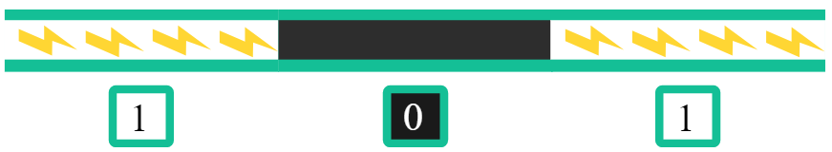

As long as the two computers agree on the time period, then they can transfer information to each other, turning binary data into signals and turning the signals back to binary data.

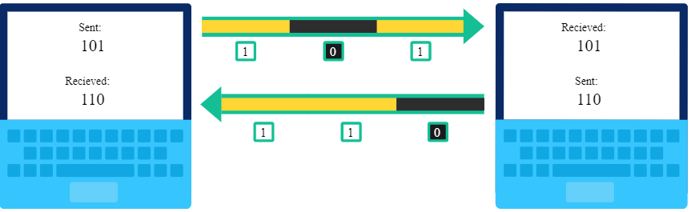

The process of turning binary data into a time-based signal is known as **line coding**. There are various line coding schemes that can be used based on the needs of the connection.

**[Skill 12.05 Exercise 1](https://hpluska.github.io/APCompSciPrinciples/ticketOutTheDoor/set8/Set8TicketOutTheDoorAPCompSciPrinciples.pdf)**

| **Skill 12.06: Define bit rate, bandwidth, and latency** |
| --- |

**Skill 12.06 Concepts**

**[Skill 12.06 Exercises 1](https://hpluska.github.io/APCompSciPrinciples/ticketOutTheDoor/set8/Set8TicketOutTheDoorAPCompSciPrinciples.pdf)**

Bit rate

Network connections can send bits very fast. We measure that speed using the **bit rate**, the number of bits of data that are sent each second.

The earliest Internet connections were just 75 bps (bits per second). These days, connections are more often measured in Mbps (megabits per second).

A megabit is huge: 1 million bits! A 10 Mbps connection transfers data at 10 million bits per second.

That's one bit every 100 nanoseconds (0.000000100 s).

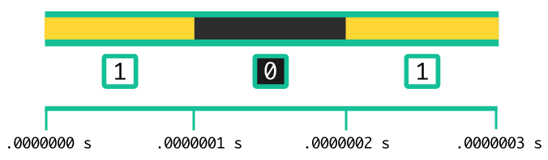

We also measure bit rate in smaller units like kilobits (1 thousand bits) or much bigger units like gigabits (1 billion bits) and even petabits (1 quadrillion bits).

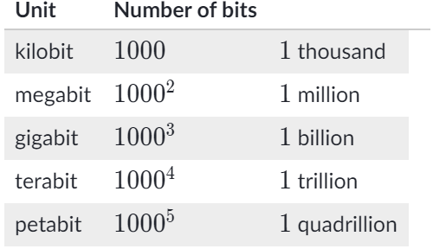

Bandwidth

We use the term **bandwidth** to describe the maximum bit rate of a system. If a network connection has a bandwidth of 100 Mbps, that means it can't transfer more than 100 megabits per second. Fortunately, that's still a lot!

Ever heard the term "broadband Internet"? That refers to a connection with a minimum bandwidth of 256 Kbps. That's enough bandwidth for basic Internet use like checking emails and reading websites, but not quite enough for watching online videos. As of 2016, only 40% of people in developing nations have access to even broadband Internet.

Latency

Another way to measure the speed of a computer network is **latency**. You might guess what that means from the word itself: latency measures how late the bits arrive. To put it in more formal terms: latency is the time between the sending of a data message and the receiving of that message, measured in milliseconds.

We typically measure the "round-trip" latency of a request. Let's walk through a real example to see what that means.

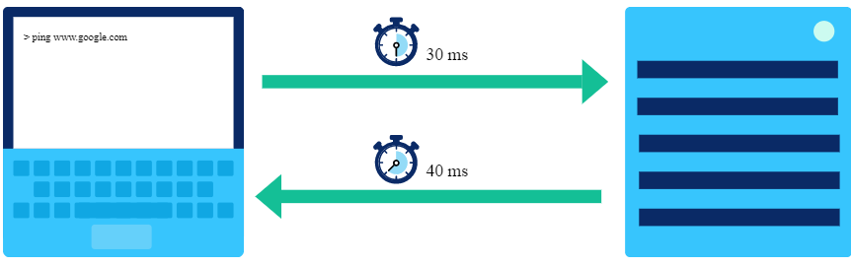

My computer sends a message to the Google server. 30 milliseconds later, Google receives the message. 40 milliseconds later, my computer gets an acknowledgement from Google that it received the message.

That's a total round-trip latency of 70 ms. The latency depends on a number of physical factors: the type of connection from my computer to Google, the distance from my computer to the Google servers, and the congestion in the network (which may mean my request has to wait in line).

There's a major limiting factor to latency: the speed of light. Nothing can move faster than light, not even our very important Internet requests. The speed of light is 1 foot per nanosecond, which means a trip length of at least 30 ms from Los Angeles to Tokyo. We can't do much about the speed of light, but we *can* decrease latency by reducing congestion and improving our physical connections.

**[Skill 12.06 Exercises 2 thru 4](https://hpluska.github.io/APCompSciPrinciples/ticketOutTheDoor/set8/Set8TicketOutTheDoorAPCompSciPrinciples.pdf)**

The video below summarizes what we’ve learned today!

|  |
| --- |
| <https://www.youtube.com/watch?v=ZhEf7e4kopM> |